Claire
For the week ending 23rd October 2015

Monday
- Discovered bug in TDP-43 code that meant the 4 pathways John discovered were only common to 4/5 data sets. Fixing caused no output at a threshold of 100 genes; therefore this was changed to 200, which produced 16 pathways.
  - Phototransduction (KEGG)
  - Starch and sucrose metabolism (KEGG)
  - Tryptophan metabolism (KEGG)
  - Complement and coagulation cascades (KEGG)
  - Prion diseases (KEGG)
  - Collecting duct acid secretion (KEGG)
  - Pantothenate and CoA biosynthesis (KEGG)
  - Dorso-ventral axis formation (KEGG)
  - Type II diabetes mellitus (KEGG)
  - Fructose and mannose metabolism (KEGG)
  - Jak-STAT signalling pathway (KEGG)
  - Fat digestion and absorption (KEGG)
  - ABC transporters (KEGG)
  - Pentose and glucuronate interconversions (KEGG)
  - Glycine, serine and threonine metabolism (KEGG)
  - Nitrogen metabolism (KEGG)

- Discovered another data set by John Ravits’ group that could be incorporated into current TDP-43 data collection. Contains RNA expression data on 12 sALS LCM motor neuron samples and 10 control samples.

Tuesday
- Began building a network with the 16 pathways in Cytoscape. Started by using Yered’s pathway coexpression network tool but struggled with the limitation of only viewing the top 50 correlated pathways.

Wednesday
- Met with personal tutor
- Aided Wenbin in increasing the usability of PCxN. I identified a bug that caused part of the menu to disappear when using a dropdown menu. This has now been fixed. I also created a mock-up of a potential design aesthetic for the webpage

- Discussed with Wenbin how PCxN could help me in my search for finding associations between my list of 16 pathways. PCxN allowed the creation of a network showing the relationship between the pathways, but as of yet I am unable to export this into Cytoscape, so may need to build my own.
- John sent me a list of static modules associated with his tracking data. Using PCxN I was able to show that there is a clear relationship between the two lists with a large amount of connectivity.

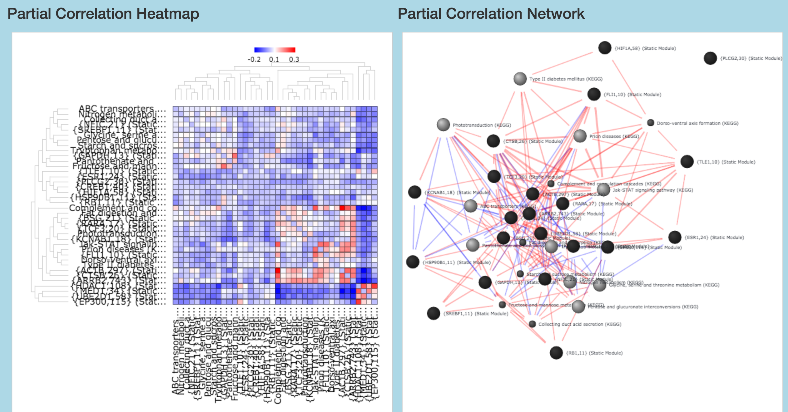

Thursday
- Began adapting John’s code to identify if the relationship between the two lists was significant – pick 10,000 lists of random static modules of equal length to John’s list and calculate if matches between my list (+associated pathways) and random lists occur less often than with John’s
- Began using RMarkdown to write methodology of TDP-43 signature search.
- Began process of integrating the Ravits data into my data set

Friday
- Identified bug in my TDP43_Signature code that meant FTLD RNA expression data was not being analysed correctly. Resulted in development of a new list:
- Complement Activation, Classical Pathway (Wikipathways)
- Complement and Coagulation Cascades (Wikipathways)
- {RAN,17} (Static Module)
- {SREBF1,11} (Static Module)
- Phase I, non P450 (Wikipathways)
- {F2,46} (Static Module)
- Tryptophan metabolism (KEGG)
- Complement and coagulation cascades (KEGG)
- Prion diseases (KEGG)
- Signaling by Insulin receptor (Reactome)
- Collecting duct acid secretion (KEGG)
- {ESR1,24} (Static Module)
- Pantothenate and CoA biosynthesis (KEGG)
- Dorso-ventral axis formation (KEGG)
- Type II diabetes mellitus (KEGG)
- {HSPA8,34} (Static Module)
- SIDS Susceptibility Pathways (Wikipathways)
- Opioid Signalling (Reactome)
- Ganglio Sphingolipid Metabolism (Wikipathways)
- Jak-STAT signaling pathway (KEGG)
- ABC transporters (KEGG)
- Nitrogen metabolism (KEGG)
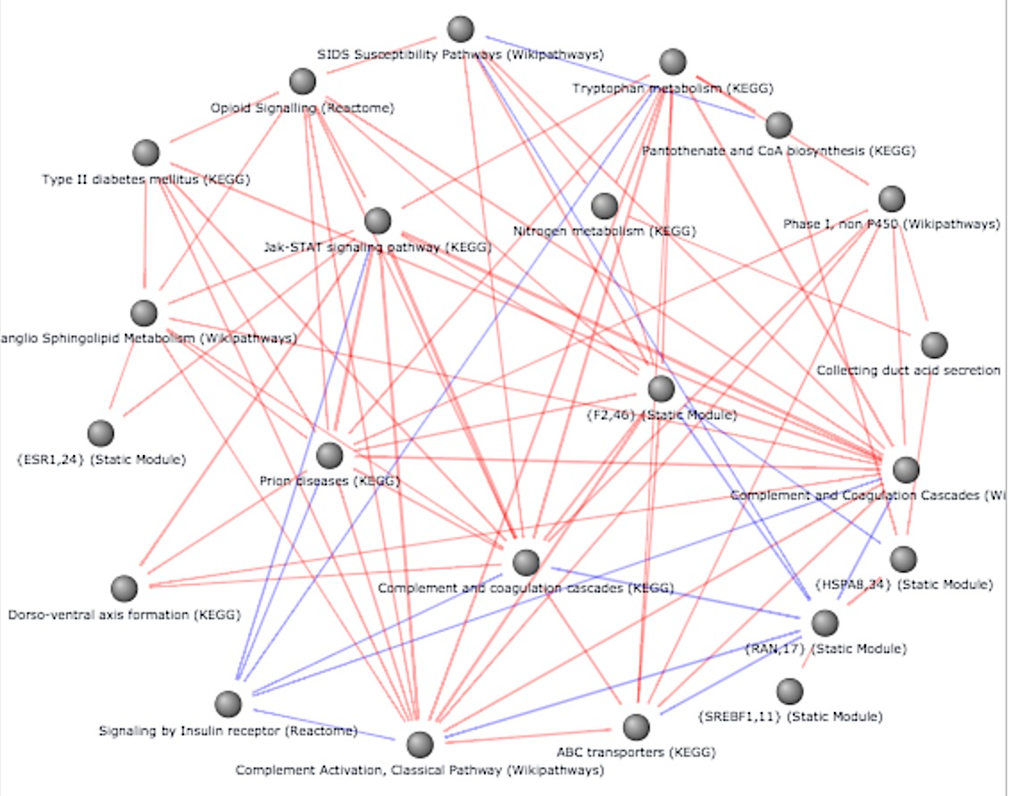

- Proposed conducting a comparison of differentially expressed pathways in ALS with TDP-43 vs ALS without TDP-43 to identify a) if there are any DE pathways in the former that are not in the latter, and b) to compare this list to the above list and identify any commonalities
- Gave Wenbin some suggestions on wording of the info boxes on the PCxN homepage
- Decided to hold off on comparison of my signature pathway list with John’s list of static modules until I am more confident. I may work on adapting the code in the mean time in preparation, depending on how much other work I have.

Next Week
- Try and incorporate the Ravits sALS data into the code and see how this affects the outcome of the common pathways
- Contact Robin Highly about how astrocyte data might be relevant
- Begin developing an equivalent to TDP43_Signature that makes comparisons between TDP-43⁺ ALS and TDP-43⁻ ALS
- Continue identifying possible improvements to PCxN. Current concerns are:
  - Problems with scrolling – if mouse hovers over the heatmap or network, it zooms rather than scrolls. Would be helpful if you had to click on the window before it zooms/have a separate zooming feature not reliant on scroll (it’s a bit sensitive)
  - Need to find a way of exporting the network and heatmap as an image file (or perhaps Cytoscape file for network). Screen shots are too difficult and produce poor quality image (see above…)
  - Networks come out quite tightly packed and you have to manually separate the nodes to be able to see the clear picture.

